CO3 Activity 5
QQ Normality

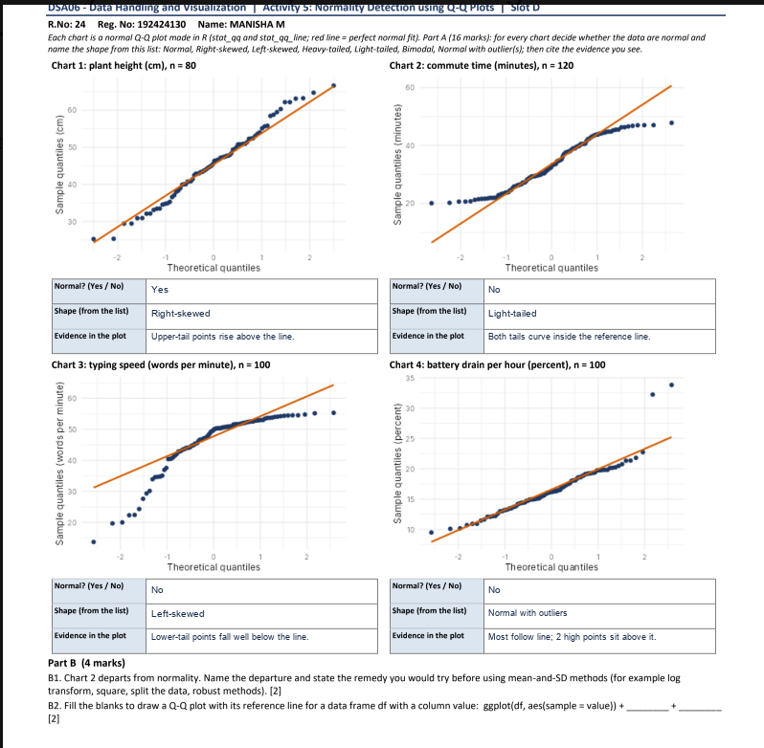

Part B Answers
B1. Chart 2 departs from normality because its Q–Q plot bends into an S shape: the points at both ends sit closer to the center than the reference line. This indicates a light-tailed distribution. Since the data do not follow a normal distribution, use robust summaries such as the median and median absolute deviation (MAD) instead of relying on the mean and standard deviation.
B2:
ggplot(df, aes(sample = value)) + stat_qq() + stat_qq_line()

